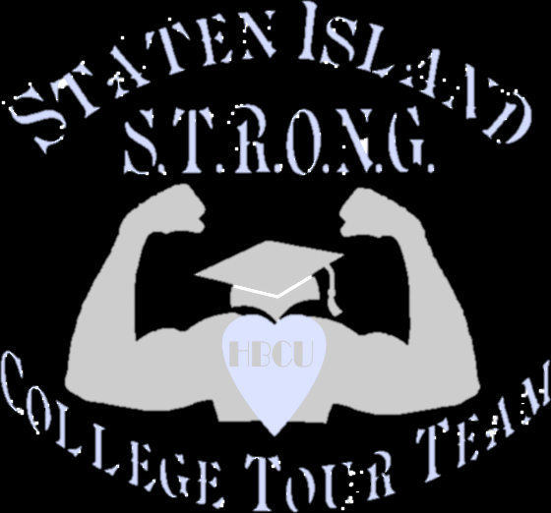
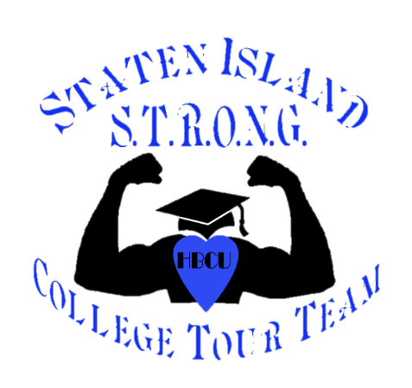
Standing Together Reaching Our Necessary Goal
“EDUCATION”
HBCU College Tour 2024
STUDENTS WHO ARE IN THE 8TH THRU 12TH GRADES AND CARRY AN 80+ AVERAGE ARE ELIGIBLE TO ATTEND THIS TOUR. {WE ARE VERY SERIOUS ABOUT THE 80 AVERAGE!} NOW IS THE TIME TO GET THE ACADEMIC HELP IF YOU WANT TO VISIT SEVERAL STATES AND FULLY GAIN THE
Historical Black College & University Experience!
We ask that you come on this tour with a great, positive attitude, seriously focused on your education and with a desire to fulfill your dreams!

Cost of the tour is $800.00 and it’s on a first come / first served basis
This covers roundtrip transportation on Academy Bus Line, Hotels, Breakfast and school tours.
THERE WILL BE A NON-REFUNDABLE REGISTRATION FEE OF $50 REQUIRED TO SECURE YOUR SEAT. THIS DEPOSIT MUST BE ACCOMPANIED BY A REPORT CARD. AND WE WILL NEED TO SEE ANOTHER REPORT CARD JUST BEFORE THE TOUR LEAVES IN APRIL.
Save The Date!
SUNDAY, APRIL 21, TO FRIDAY, APRIL 26, 2024
North Carolina A&T ★ North Carolina Central University ★ Spelman College ★
Morehouse College ★ Clark Atlanta ★ Morris Brown College ★
Morgan State University ★ Howard University
SCHOOLS SUBJECT TO CHANGE!

www.sistronghbcu.org

Dear Parents,
STANDING TOGETHER, REACHING OUR NECESSARY GOAL … EDUCATION!

The HBCU College tour will be leaving on Sunday, April 21st, and returning on Friday, April 26th, 2024. Every student is required to have an academic average of 80 or above. The cost of the tour is $800.00. This includes transportation, hotels, breakfast, and campus tours. Students will need money for lunch, dinner, and souvenirs. Enclosed you will find:
- Student application sheet
- Parent Consent Form
- Code of Conduct Form
- Parent/Guardian information sheet
- Emergency/Medical Release form
- Personal Reference sheet
- School Reference sheet
- Student Essay Sheet
- Student Vaccination Verification.
*Every sheet is to be completed in a timely manner. Applications will NOT be accepted if not complete. The $50 registration fee (non-refundable) and a most recent report card must be handed in along with the application (this fee will be deducted from the $800). This will guarantee your child a seat on the bus. This is on a first come first served basis.
*All payments must be paid in full by March 1, 2024. We accept cash, PayPal, check or money orders payable to: SI STRONG HBCU College Tour.
*We also require some participation from the parents/guardians! There will be personal interviews conducted with both the student and the parents (separately) and several workshops will be scheduled with important information that will help to guide the college application and scholarship process.
*Attendance is REQUIRED at the interview and at least one of the workshops by both the student as well as the parents/guardians. We will share the dates and times of these as soon as possible.
We look forward to expanding the future of our youth!
Sincerely,
THE STATEN ISLAND S.T.R.O.N.G. HBCU COLLEGE TOUR TEAM
Any Questions please feel free to contact:
★JESSIE BARNES 718/806-7970 ★ JENNIFER WATKINS 646/675-8301 ★ MAURICE HYDE 646/295-6107
★KELLY ETHERIDGE 917/833-2447 ★ CHRISTY EKPE 646/552-1750 ★ ARTHUR MARTIN 917/531-8700 KENDALL RICHARDSON 347/524-9118 ★ ELAINE SMITH 347/423-8785 ★ MOSEZETTA OVERBY 917/626-0462 SERENA BROTHERS-MOHAMED 718/506-5198 ★ INGA WILSON-HYDE 646/326-1175

STANDING TOGETHER REACHING OUR NECESSARY GOAL … EDUCATION!
PARENTS CONSENT FORM
This is to certify that I/we give my/our permission for my child to participate in the college tour on Sunday April 21th and returning on Friday April 26th, 2024. I realize that my child will be transported by bus and that he/she is under the direct supervision of the person or persons of the Staten Island S.T.R.O.N.G. HBCU College Tour Team. I hereby confirm that the Staten Island S.T.R.O.N.G. HBCU College Tour Team have advised my child that he/she is prohibited from participating in any misconduct or improper acts while on this trip. Including, but not limited to, refraining from the use of any alcoholic beverage, or illegal substances, and for causing or participation any property damage, from creating any disturbance or doing or participating in any illegal acts. (initial)

I do hereby consent to reasonable discipline and disciplinary measures being imposed by the Staten Island S.T.R.O.N.G. HBCU College Tour Team. This consent shall include, , the right to impose reasonable limitations on the activities and movements of my child. (initial)

I do hereby consent and give permissions to the Staten Island S.T.R.O.N.G. HBCU College Tour Team to obtain any medical and /or hospital care or treatment that may be required by my child. I agree that any medical and /or hospital treatment that is covered by my insurance plan shall be promptly submitted by me to the hospital. I agree to pay the costs incurred for such medical and/or hospital expenses that may arise during the college tour. (initial)

The telephone numbers at which I may be reached are: or .

I understand that if, for any reason my child must be sent home from the tour, all related expenses are my responsibility. (initial)

I do hereby agree to hold SI S.T.R.O.N.G. HBCU College Tour Team and its subsidiaries, employees, officers, directors, or other agents blameless for any damages, penalties, fines, suits, actions, or other costs (including reasonable attorneys’ fees) arising out of or in connection with any violation of any local, state or federal law, rule, regulation or ordinance
related to their child’s participation in the “College Tour”. (initial)
I, the undersigned have read, understand and agree to the terms and conditions mentioned in this application. PARENT/GUARDIAN Date
PARENT/GUARDIAN Date

SI S.T.R.O.N.G. Team Member Date

STANDING TOGETHER REACHING OUR NECESSARY GOAL … EDUCATION!

Code of Conduct

Expectations for Students:
Please remember and discuss with your child that this is a very special trip and that we will be guests of the College/University. Students’ conduct must be outstanding at all times. Students must be reminded that they are to follow S.I. S.T.R.O.N.G. HBCU College Tour Team’s staff instructions at all times to ensure the entire group’s safety and general well-being. Failure to do so may result in consequences, such as the student not being able to continue the Tour.

Consequences for Students:
Depending on the severity of an incident that occurs on the tour, a student may be sent home from the college/university at the expense of the parent. In this event, a parent or guardian will be notified immediately and will be expected to come and pick up the student immediately. SHOULD THIS BECOME NECESSARY, ALL EXPENSES RELATED TO THIS INCIDENT ARE THE RESPONSIBILITY OF THE PARENTS OR GUARDIANS.

Examples of incidents that will result in immediate removal from the trip include, but are not limited to, the following:
*fighting
*stealing
*destruction of property
*bullying
*lying, and/or falsely accusing another student
*drinking alcohol or the use of any illegal substance, drugs etc.
*harassment (sexual improper behavior)

PARENT/GUARDIAN Date

PARENT/GUARDIAN Date

SI S.T.R.O.N.G. TEAM MEMBER Date

STANDING TOGETHER REACHING OUR NECESSARY GOAL … EDUCATION!
★STUDENTS APPLICATION/INFO★
STUDENTS NAME DATE OF BIRTH AGE MALE FEMALE ADDRESS CELL# EMAIL# SCHOOL NAME GRADE SCHOOL ADDRESS
SCHOOL PHONE# IEP? Yes or No PLEASE PRINT YOUR PARENT/GUARDIAN NAME(S) AND CELL #

THIS APPLICATION WILL NOT BE CONSIDERED COMPLETE WITHOUT THE FOLLOWING ATTACHMENTS:
□ COPY OF MOST RECENT REPORT CARD
□ STUDENT INFO SHEET
□ RECENT PHOTO (PASSPORT SIZE)
□PARENT/GUARDIAN INFO & CONSENT FORM
□EMERGENCY & MEDICAL RELEASE FORM (including copy of Medical Insurance card)
□ (1) SCHOOL REFERENCE
□ (1) PERSONAL REFERENCE
□ COMPLETED ESSAY
□$50 REGISTRATION FEE
□ VACCINATION VERIFICATION

STUDENTS SIGNATURE DATE

STANDING TOGETHER REACHING OUR NECESSARY GOAL … EDUCATION!

★PARENT/GUARDIAN INFORMATION★
STUDENTS NAME

PARENT/GUARDIAN Relationship

PARENT/GUARDIAN Relationship

ADDRESS:

HOME# CELL# WORK#

EMAIL:

PLEASE ANSWER THE FOLLOWING QUESTIONS:
★ WHY WOULD YOU LIKE YOUR CHILD TO ATTEND THE COLLEGE TOUR?

★WHAT ARE YOUR EXPECTATIONS FOR YOUR CHILD WHILE ON THIS COLLEGE TOUR?

I/We have reviewed the completed application and attest to the accuracy of its contents

PARENT/GUARDIAN SIGNATURE DATE

PARENT/GUARDIAN SIGNATURE DATE

STANDING TOGETHER REACHING OUR NECESSARY GOAL … EDUCATION!
★EMERGENCY CONTACTS & MEDICAL RELEASE FORM★
*** This Form MUST Be Notarized ***
STUDENTS NAME
Is your child on any medication that they need to take while on this tour: Yes No Does your child have any behavioral issues (for example: ADHD, ADD, bipolar, mood or conduct disorder)? Yes No
Does your son/daughter have any allergies (food,nuts,etc.) we need to be aware of: Yes No
★If Yes to any question above please list below★
Allergies/Allergic to:

Medications taking:

Details:

★Please list 2 Emergency Contacts★
EMERGENCY CONTACT #1 CELL# EMERGENCY CONTACT #2 CELL# I HEREBY AUTHORIZE THE STAFF/VOLUNTEERS OF THE STATEN ISLAND S.T.R.O.N.G HBCU COLLEGE TOUR TEAM TO OBTAIN EMERGENCY MEDICAL TREATMENT, IF NECESSARY, FOR MY CHILD WITH THE UNDERSTANDING THAT THE FAMILY WILL BE NOTIFIED AS SOON AS POSSIBLE.

Parent/Guardian Signature(s) Parent/Guardian Signature Date

STANDING TOGETHER REACHING OUR NECESSARY GOAL … EDUCATION!

★SCHOOL REFERENCE★
STUDENTS NAME SCHOOL NAME REFERENCE NAME POSITION/TITLE CONTACT# EMAIL

PLEASE ANSWER THE FOLLOWING QUESTIONS:

HOW LONG HAVE YOU KNOWN THIS STUDENT?

BRIEFLY DESCRIBE THE NATURE OF YOUR RELATIONSHIP WITH THIS STUDENT

PLEASE GIVE 3 QUALITIES OR CHARACTERISTICS ABOUT THIS STUDENT

WHAT WOULD YOU CONSIDER HIS/HER WEAKNESSES and STRENGTHS?

STANDING TOGETHER REACHING OUR NECESSARY GOAL … EDUCATION!

★PERSONAL REFERENCE★
STUDENTS NAME REFERENCE NAME CONTACT # EMAIL PLEASE ANSWER THE FOLLOWING QUESTIONS
- HOW LONG HAVE YOU KNOWN THIS STUDENT
- BRIEFLY DESCRIBE YOUR RELATIONSHIP WITH THIS APPLICANT

- GIVE AT LEAST 3 QUALITIES OR CHARACTERISTICS THAT YOU FEEL WOULD WARRANT THIS STUDENT TO ATTEND THIS COLLEGE PREPARATION PROGRAM. HOW DO THESE QUALITIES RELATE TO THEIR PARTICIPATION?

- WHAT WOULD YOU CONSIDER TO BE THIS STUDENTS STRENGTHS AND WEAKNESSES?

STANDING TOGETHER REACHING OUR NECESSARY GOAL … EDUCATION!

★STUDENT ESSAY★
STUDENTS NAME
Please write or type a one-page essay explaining why you would like to go on this college tour
and what you hope to gain from the experience.

COVID-19 POLICY
General. Many cities, states, colleges, and universities require all students and visitors coming onto campuses to be fully vaccinated (and at times boosted) against COVID-19 to minimize outbreaks and promote the community's public health, consistent with federal, State, and local efforts. In some cases, S.I. S.T.R.O.N.G. may be required to ensure all guests are fully-vaccinated and present proof to the College/University before entering campus grounds. To promote public health wellness and remain compliant with the varying jurisdictions, please submit the following documentation:

Vaccination verification:
  - A copy of the vaccination card indicating proof of vaccination. (Fully vaccinated means two weeks after the second dose of the Moderna or Pfizer/BioNTech or Novavax vaccine or two weeks after the single dose of the Johnson & Johnson vaccine. These are the only four vaccines authorized in the U.S. by the U.S.
F.D.A. and recommended by the C.D.C. Advisory Committee on Immunization Practices (A.C.I.P.).

Proof of vaccination means:
    - A completed CDC COVID-19 vaccination record card; or
    - Documentation signed by a U.S. licensed healthcare provider; or
    - A New York Excelsior Pass

Exemptions may be given on a case-by-case basis for medical or religious reasons. They are not automatically granted. Having had COVID-19 does not provide an exemption. ANY REQUEST FOR AN EXCEPTION MUST BE ACCOMPANIED BY A PHYSICIAN'S STATEMENT THAT YOU ARE UNABLE TO GET THE VACCINATION.

Proof of a negative Covid-19 test result.
Regardless of vaccination status, all participants must present a negative COVID-19 test result. PCR test or a self- administered Rapid Antigen Test (R.A.T.) taken within 3 days of boarding the bus.
Acceptable proof of a negative test includes a printed document or email with the results from the test provider or lab three (3) days prior to travel. For R.A.T. results, take a picture of the negative test results. Write the name of the person tested and the date of the test on the test.
Face masks are required while traveling on the bus, and other venues requiring masks. (Please bring sufficient mask)
The Parent/Guardian of any participant who contracts Covid-19 during the trip will be notified. Parents/Guardians shall, at their OWN expense, come and get their child to quarantine and return home. Guests who test positive for Covid-19 will not be allowed to complete the tour.

S.I. S.T.R.ON.G. reserves the right to change this policy, including due to the progress of the COVID-19 pandemic and guidance from governmental authorities.
I/We have reviewed the COVID-19 policy and agree to abide by the abovementioned terms.

PARENT/GUARDIAN SIGNATURE DATE

PARENT/GUARDIAN SIGNATURE DATE

STUDENT SIGNATURE DATE

